State user

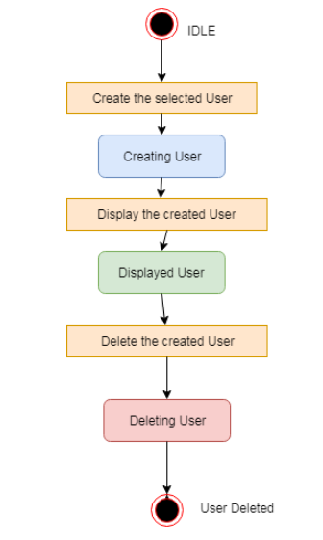

State product

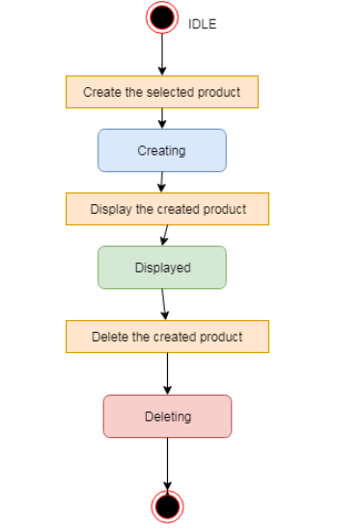

State Tab

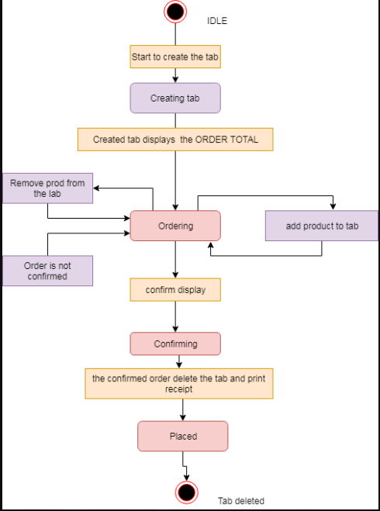

Sequence Diagram

Admin Process

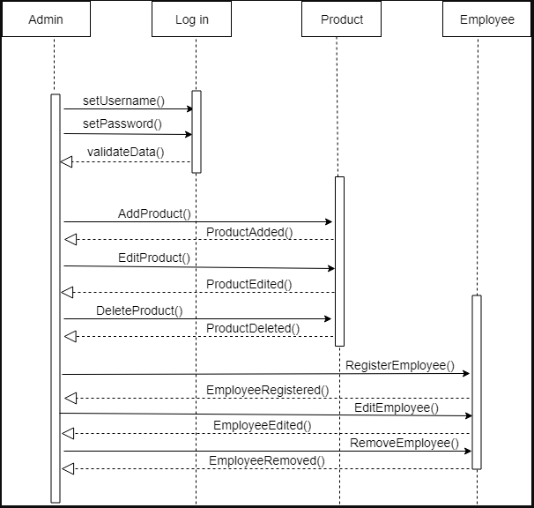

Data Flow Diagram

DFD (level0)

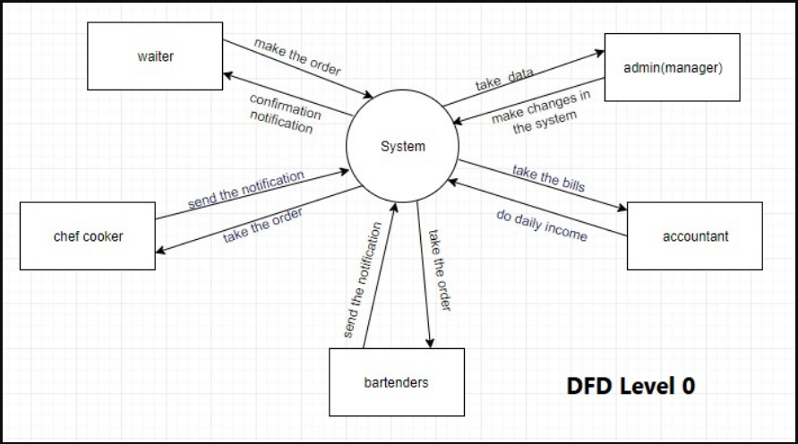

DFD (level 1)

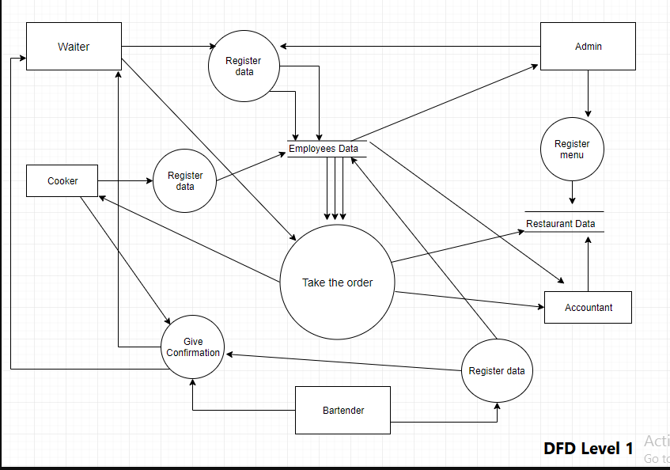

DFD (level 2)

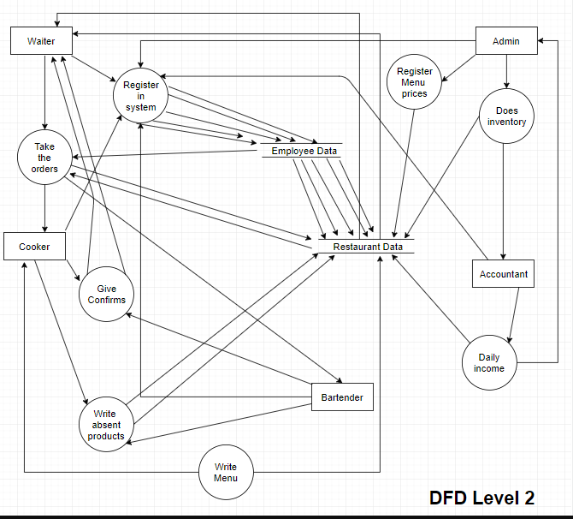

DFD (level 3)

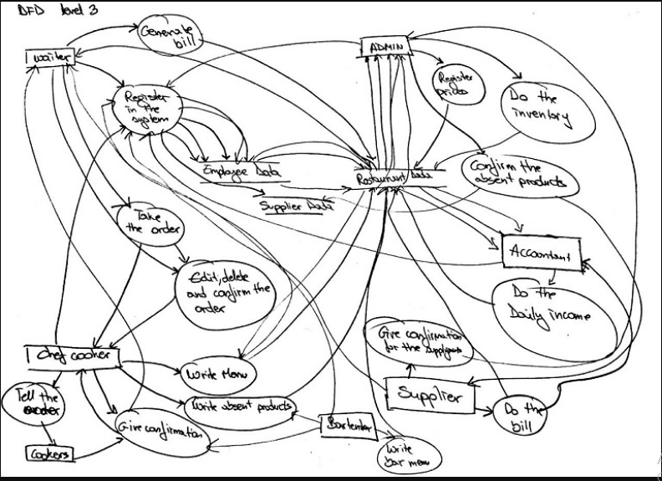

DFD (level 4)

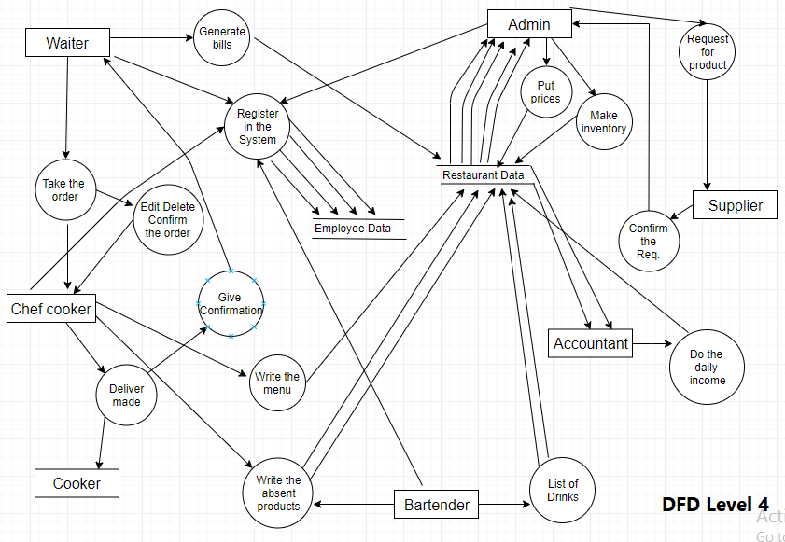

Class Diagram

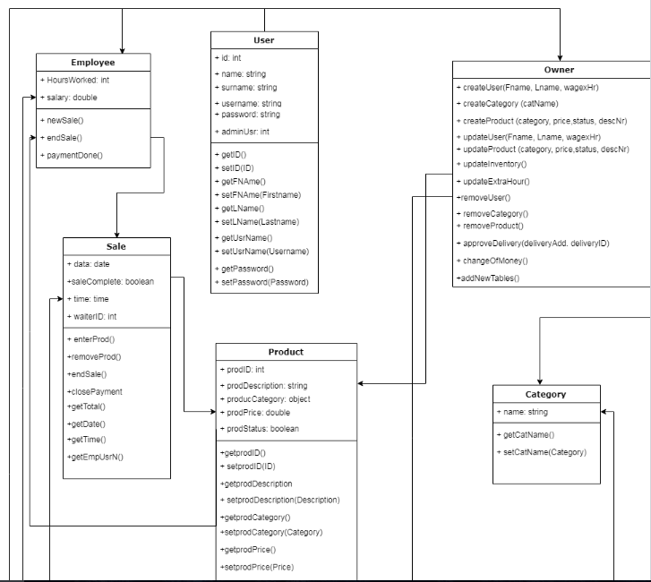

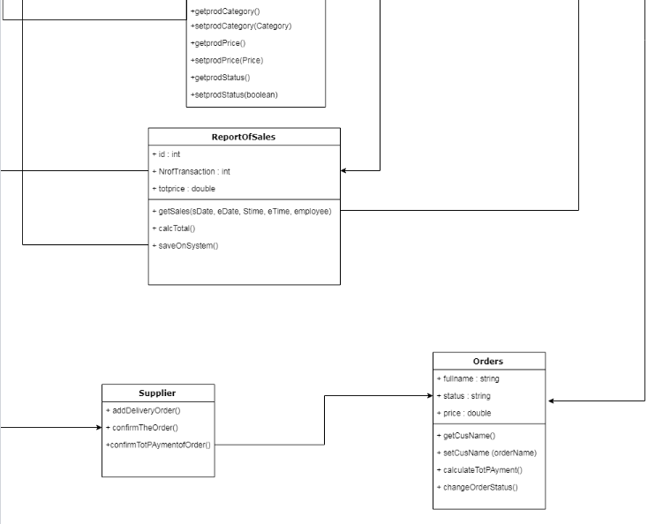

ERD diagram

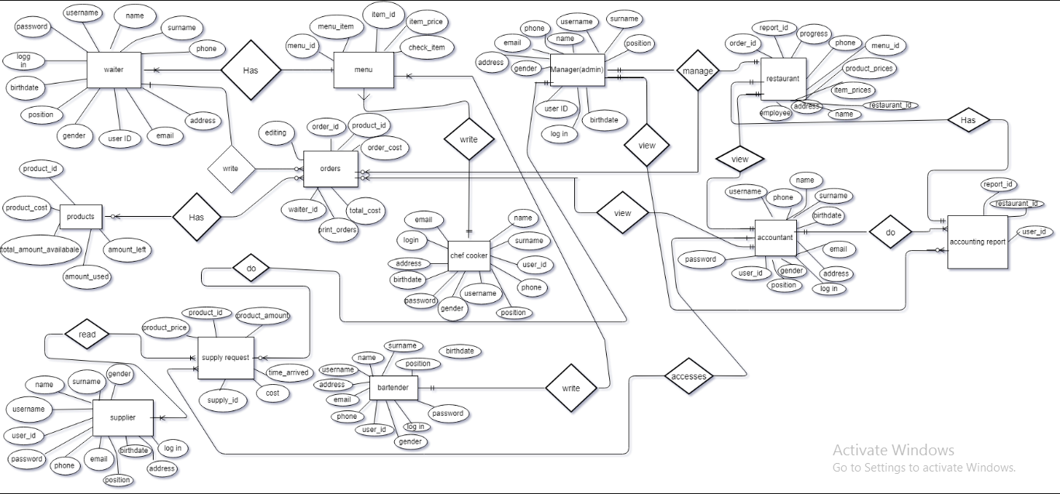

Component Diagram

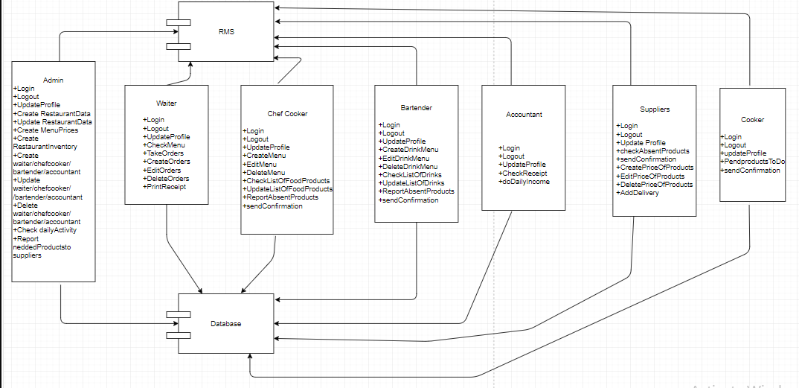

Restaurant Management System
Requirements Specification
Version 1.0
April 01, 2019



Author Note:
Binf Department
CEN 302 – Software Engineering
RMS Team:
Eneida Berisha
Erblin Zekthi
Kei Vrapi
Visara Krrashi
Xheni Sollaku
Table of Contents
1. Executive Summary 3
1.1 Project Overview 3
1.2 Purpose and Scope of this Specification 3
2. Product/Service Description 3
2.1 Product Context 3
2.2 User Characteristics 3
2.3 Assumptions 3
2.4 Constraints 3
2.5 Dependencies 4
3. Requirements 4
3.1 Functional Requirements 5
3.2 Non-Functional Requirements 5
3.2.1 User Interface Requirements 5
3.2.2 Usability 5
3.2.3 Performance 6
3.2.4 Manageability/Maintainability 6
3.2.5 System Interface/Integration 7
3.2.6 Security 8
3.2.7 Data Management 8
3.2.8 Standards Compliance 8
3.2.9 Portability 8
3.2.10 Other Non-Functional Requirements 9
3.3 Domain Requirements 9
4. User Scenarios/Use Cases 9
APPENDIX 10
Appendix A. Definitions, Acronyms, and Abbreviations 10
Appendix B. References 10
Appendix C. Requirements Traceability Matrix 10
Appendix D. Organizing the Requirements 12

Executive Summary

Project Overview
The Restaurant Management System projects represents building a software, the aim of which will be to easier the management of a Restaurant, through efficient implementation of programing part and also businesses concept, both fit on the software. The software will include the functionalities as are:
- Users/Admin will be able to log in and each of them will have their own sessions. Admin have its rights to add new users or new categories as needed.
- Waiters take the orders and select the orders from the menu category that is on the application, he can edit the order according to client’s desire, and generate also the bill when order is finished.
- Chef of the kitchen use the application to take the order and to write what is sold during the day.
- Accountant take all the bills directly as the waiter has done the order.
- The manager controls everything online and in the end takes the reports of what is sold, what is consumed, what is to be ordered to supplier, what is the profit.
- The supplier will automatically take the list of the products of the restaurant they want to buy and the date when they want to buy it.
So with this software they will be:
- Keeping track of sales.
- Generating bills.
- Keeping track of consumed products.
- Recording the work that is done.
- Keeping track of purchases.
- Ensuring that taxes are accounted in the right way.
Everything will happen in the eyes of everyone, everyone knows what the other is doing and at the same time everyone is the owner of their site. The software helps the manager to better manage the restaurant due to the fact that everyone wants to better manage themselves. This software will help the owner to rely on everybody’s jobs, and to know on real time how is it going with the business.

1.2 Purpose and Scope of this Specification
The Restaurant Management System will be designed with the purpose of having the capabilities and features to help operation and management of the restaurant. The easiest thing to do is opening a business, but what turns it to a success is the management system. Management system is the primary key of a business, through management we coordinate the restaurant activities in such a way to provide profit, because the aim is profitability. This is why we focus on management and we are creating our project to give a better alternative for the management. Our software will help manager to manage the restaurant easier, more efficiently and cheaper not only in time but also on money. It will be more clear and easier for the manager to track everything and the owner can better check the restaurant activity. The main responsibility is on the waiter since they are the first link of the chain, so we aim to make keeping orders easier, faster and give the option of editing the items of the menu, also generating checks and changing the tables.

Product/Service Description
To manage efficiently, the manager should know everything in detail, coordinate everyone and everything they do and also control. Controlling is the most important, but you cannot stay on the head of everyone checking what and how they do, so to solve this problem we give the application, online application, so everyone will know what is done. The control and management of every section are what keep a business alive. Our software will help the restaurant to have control over everything, to know all the backstage of ordering, cooking, accounting and managing. This software will be very beneficial for the restaurant in many directions such as:
- It will cut the time needed to serve and to control.
The waiter do not have to write the order, they just have to click on the item (clicking over it according to the quantity ordered so if they want for example two pasta just double click over the pasta and you did it). The cooker does not have to wait for the waiter to give the order to him, they take it online as the waiter has confirmed the order. The bartender also can prepare the drinks as soon as possible. So the clients do not have to wait too long, and everyone can do their job very easily. The waiter does not have to take time rewriting the order to generate bill since it will generate automatically as the waiter has clicked done to the order. The accountant does not have time to print each bill, that is why our application makes it easier since the bills will be send directly to the printer after the waiter confirms the order. No check all over the kitchen is needed since the chef of the kitchen will report at the end of the day what is consumed on its own site. The manager does not have to go to everyone and see how it is going since he has access on every process.
- Everyone will do the job with honesty since they are under control.
- It will increase the responsibility since everyone will feel important and will decide for what they do.
- The stress will be reduced since everyone is keeping record for their job they do not have to be afraid they someone will blame them unfairly. Also since they take the order faster they get more time to prepare the ordered items.
- It will promote the best workers at the end of each week. The records will show out which one of them does more profits and they may get awards for their skills.
- Faster management and reliable system.

Product Context
Our management software will be based on the Era Restaurant. It will be used by every employee of the restaurant: waiters, bartenders, cookers, chef of the kitchen, accountant, the managers, the owner. Everyone will have access on every detail of the software, based on what they are specialised for. Everyone will manage their site, despite the manager, accountant and the owner that will have access on other sites to. We aim to sophisticate the current management system of Era Restaurant.

User Characteristics
The users that will interact within the system are:
- Waiters.
- Bartenders.
- Cookers and chef cooker.
- Accountant.
- Suppliers.
- Manager.
- Owner of the restaurant.

- Waiters
The waiters first of all will login, then the number of tables will appear on the screen so he will select the number of the table serving, he will continue with the order he will have access on all the menu categories: breakfast menu (fixed), appetizers, salads, entrees, side items and beverages. The waiter will click first on the section of the menu the client is ordering. It will also have the option edit, to edit an item that the client wants it special, for example a Greek salad without onions. Also can drop something selected. As the waiter select the item its price is on its side so it will automatically generate the bill. The bill will also go to the accountant. The bill will be connected with a printer to print it. The site of the waiter user is connected with all the other users. The waiters can see the day’s income and the products sold. When he closes his shift, he logs off. When the other waiter login, the income starts with 0, so everyone can check out how much income they have made during the shifts. The incomes cannot be changed.

- Bartenders will first login, after that they will receive from the waiter the products that he has selected, the bartender has access only on the drinks menu. They have only one option; check, when they have prepared the products needed. At the end of their page they get some notes if they have missed any order. And they also has an option to discount from the overall quantity every drink that is consumed.

- Cookers and chef cooker
The chef cooker that has the shift first should login. After that he is responsible to write the amount of each ingredient he has on his personal site. After that they wait the order from the waiter, automatically the order arrives at the chef cooker as long as the waiter has clicked done. The cookers are separated in groups according to their specific products and everyone prepare their products. As long as someone has finished an order, he clicks done to the product he prepared. When the order is all finished, the chef cooker clicks done button and the waiter come and takes it. At the right hand of each menu item it is written a fixed amount of ingredients compounded on a specific food. They can add an extra ingredient or can drop, so in this way, the chef can take notes and write what is needed and what is missing (for the supplier). In this way, everything that is consumed from the kitchen is recorded and is discounted from the overall amount of that product that he has configured at the beginning of his shift and the current amount is showed up. So when he logs out, the next chef knows how much amount of ingredients he has available. The same thing applies for the second chef also, so they can get a report to what is consumed and they know exactly what to tell the manager, when to do the purchasing and how much quantity they need for every product.

- Accountant
Accountant is all the time one person so he has to login one time. He has access on waiter’s site since he generates the bills and also on the purchasing that is required by the cookers and bartenders. The accountant’s page is connected with a printer to print these bills and to document them.

- Suppliers
Suppliers have access on the software. The contact numbers of them are connected with the system so when the restaurant is running out of stock of a product they get a message about the quantity and what product they need to deliver to the restaurant and through another message the manager is notified for their approval.
They have the access to login on the application.

- Manager
Manager knows everything before anyone else will know. He has access over every possible page, has the right over every other user except the owner. After he controls everything that happens around the restaurant, he checks if all the items of the menu, with the respective amounts are declared correctly. After he controls the sales, the time that the product is served (he notice it through how time it takes for the workers to click the done button). The manager can add/drop/edit items that he observes that are not preferable, or add a new item or edit an item to bring a new taste.

- Owner of the Restaurant
Owner is the one that has the all power. The eye that can see everyone and check that everyone is doing as he want the job, in the best way. He has access everywhere, he can add, drop, edit, or exclude any product he wants. He has the opportunity to accomplish or to punish someone, since he can check the income taken by anyone and the honesty and the fairness everyone has done with his own dutty.

Assumptions
- It is assumed that the business is registered by their representative.
- It is assumed that the waiters and the manager have enough information to use these system since it is very easy no difficulties will arise.
- It is assumed that they are two printers one for the waiters, one for the accountant connected with the software.
- It is assumed that the waiters after printing the bill cannot delete it or turn it back.
- It is assumed that the manager cannot make any change at the end of the day after the daily income is closed.
- It is assumed that every bill is documented in the software and also in hard copy so no trick can be done by accountant or manager.
- It is assumed that a regular and correct control over the available products is done at the beginning of the day and also at the end of the day so no unexpected situation will happen.
- It is assumed that the waiters nor anyone else can exchange passwords and can be logged in as someone else.
- It is assumed that every event that occurs in the software system is saved.
- It is assumed that a monthly and yearly inventory is made by an accountant according to the law.
It is assumed that some actions performed behind the scenes are performed regularly according to law. Therefore users under Drejtoria e Informacionit, who confirm the assistance, according to law Nr.9049, date 10.4.2003, “PËR DEKLARIMIN DHE KONTROLLIN E PASURIVE, TË DETYRIMEVEFINANCIARE TË TË ZGJEDHURVE DHE TË DISA NËPUNËSVE PUBLIKË”, we assume that every employee that is part of the restaurant is declared and secured according to the law.

Constraints
The project is constrained by the Internet connection. Since the application fetches data from the database over the Internet, it is crucial that there is stable Internet connection for the application to function.

Dependencies
In order for this application to work we must frequently gain access on the database.

Requirements
Priority Definitions

Functional Requirements

Req# | Requirement | Comments | Priority | Date Rvwd | SME Reviewed / Approved
BR_RS_01 | The software should provide different interfaces for users, managers and the owner | The view for waiter, chef cooker, manager and  owner will be different | 1 | 02/04/19 | Erblin Zekthi/  Kei Vrapi
BR_RS_02 | The system should check if the user is available in the database | The specified username and password is already registered in the database | 1 | 02/04/19 | Erblin Zekthi/  Kei Vrapi
BR_RS_03 | The user accounts should be secured with passwords | The password textbox should hide the text. | 1 | 02/04/19 | Erblin Zekthi/  Kei Vrapi
BR_RS_04 | After the waiter logging, in the software should be present the user with the products available and a tab to filter and select these products | The basic interface to be  used by the waiter to select a specific product | 1 | 02/04/19 | Erblin Zekthi/  Kei Vrapi
BR_RS_05 | The user is able to add products to the currently opened tab and print the bill through the printer | Adding, removing and finalizing a tab for a specified table | 1 | 02/04/19 | Erblin Zekthi/  Kei Vrapi
BR_RS_06 | The owner is able to add/remove user accounts | Has the ability to edit the list of waiters who can access the software | 1 | 02/04/19 | Erblin Zekthi/  Kei Vrapi
BR_RS_07 | The manager and owner can view all the service records according to the search criteria or by default | When manager or owner searches for a specific item that exists on the database, it will show all the specific information about that item | 1 | 02/04/19 | Erblin Zekthi/  Kei Vrapi
BR_RS_08 | The waiter, bartender, cookers and accountant are able to update their passwords and username, but not their first and last name. | If someone will forget their  passwords they can use forget password option | 1 | 02/04/19 | Erblin Zekthi/  Kei Vrapi
BR_RS_09 | There will be a tab on waiters view where he will have product categories listed | Product categories will be showed on a specific tab which will be managed by the waiter when the customer orders | 1 | 02/04/19 | Erblin Zekthi/  Kei Vrapi
BR_RS_10 | When the order is processed it will be shown to the bartender which after will produce the required product | The bartender will be able to see what drinks are being ordered immediately after the waiter confirms the order | 1 | 02/04/19 | Erblin Zekthi/  Kei Vrapi
BR_RS_11 | The price will be added  Automatically together with the ordered product and the ordered amount. If there will be any update on the order, the price will be updated again | Whether there is an order it  will be shown together with  the price and it will be updated immediately at the time another product is added or removed | 1 | 02/04/19 | Erblin Zekthi/  Kei Vrapi
BR_RS_12 | The payment will be done when the costumer asks for the bill and after that, the waiter can close the table from the software | The waiter will need to declare the table as open after the customers leave | 1 | 02/04/19 | Erblin Zekthi/  Kei Vrapi
BR_RS_13 | Every ordered product is being printed to a second, which is managed by the accountant | The accountant keep tracks of the receipts, so he prints them | 1 | 02/04/19 | Erblin Zekthi/  Kei Vrapi
BR_RS_14 | If there is any product running low, it will give an alert on chef cooker to supply the restaurant with the required products | In order not to have missing products on the restaurant, there will be an alert to the chef cooker showing that there are only a few products of a current type left, so the manager can order some more from that product. | 1 | 02/04/19 | Erblin Zekthi/  Kei Vrapi
BR_RS_15 | If there is any product running low from the drinks section, it will give an alert on manager to supply the bar with the required products | In order not to have missing drinks on the bar, there will be an alert to the bartender showing that there are only a few drinks of a current type left, so the manager can order some more from that product. | 1 | 02/04/19 | Erblin Zekthi/  Kei Vrapi
BR_RS_16 | The cookers are separated in groups, regarding what they are specialized for. | One is specialized for fish, one for meat, one for breakfast, one for side dishes, one for desserts, etc. | 1 | 02/04/19 | Erblin Zekthi/  Kei Vrapi
BR_RS_17 | The cookers login and they have a tab where they see the products available. Every time they login, they have the products displayed on their interface | For example, the cooker specialized for fish product, has only the fish products on its interface | 1 | 02/04/19 | Erblin Zekthi/  Kei Vrapi
BR_RS_18 | The cookers have the option to add and remove the ingredients from their interface when they are consumed by the client or added by the supplier | Every time they use specified ingredients, they remove it from the software, so in the end of the shift, the chef cooker takes the report of what is needed and what is missing | 1 | 02/04/19 | Erblin Zekthi/  Kei Vrapi
BR_RS_19 | The cookers select ‘done’ when their preparation for a specific product is done. | From the application, they should notify the chef cooker every time they finish with their preparation part | 1 | 02/04/19 | Erblin Zekthi/  Kei Vrapi
BR_RS_20 | The chef cooker controls all the kitchen. He logs in and when the order is ready, he notifies the waiter through the ‘done’ option to come and get it | The chef cooker press ‘done’ after all the preparation from the cookers is over. | 1 | 02/04/19 | Erblin Zekthi/  Kei Vrapi
BR_RS_21 | The chef cooker can see all the products missing from the kitchen and in the end of its shift, he prepares a report and send it to the manager | The chef cooker is responsible for all the products in the kitchen | 1 | 02/04/19 | Erblin Zekthi/  Kei Vrapi
BR_RS_22 | The manager controls the activity of all the workers. He logs in and his interface is divided into waiters list, products sold, drinks sold, daily income for each waiter and daily income in total. | The manager is responsible for every activity happening in the restaurant and the bar, through the software he has the ability to prevent any inconsistency happening on real time, he can check the waiter’s job during their shift and can check on real time if a product is running out of stock. | 1 | 02/04/19 | Erblin Zekthi/  Kei Vrapi
BR_RS_23 | The manager gather reports from the chef cooker and bartender about the products missing and can contact the supplier immediately through the software | He sends a message to the supplier through the software with the report they need for the restaurant. | 1 | 02/04/19 | Erblin Zekthi/  Kei Vrapi
BR_RS_24 | The owner of the company logs in and has the same interface as the manager but he also can add, edit, or drop any product from the menu of the bar or restaurant. | The owner can also punish or fire the workers from the restaurant, regarding their working session. | 1 | 02/04/19 | Erblin Zekthi/  Kei Vrapi
BR_RS_25 | The accountant logs in. It has all the records from the waiter and bartender and prepared inventories for the restaurant each month and year. | The accountant is a single user. | 1 | 02/04/19 | Erblin Zekthi/  Kei Vrapi
BR_RS_26 | The software should apply  the VAT automatically | Before printing the receipt, the VAT (20%) will be calculated and displayed separately in the receipt | 1 | 02/04/19 | Erblin Zekthi/  Kei Vrapi

Non-Functional Requirements

User Interface Requirements
The criteria is the user interface should be web compatible. It must have different screen resolution and appearance based on the device used by the user.
First of all the employee that has access on the software will see a login screen where the employee can put on their credentials as are username and password. After a successful login they will be redirected to their appropriate view.
Depending on the user that has log in will depend also the view of the page. Differential sites inside the software to support in an efficient way every worker’s duty.
Notification will notify waiter when an order is finished.
Responsive simple design.
Owner of the restaurant can access the system by creating other user profiles.
When regular users are login the next view is that of the products that is provided by the restaurant. Waiters has the view of the menus (food menu (that are subdivided on different categories) and drink menu). Bartender has the menu of drinks and drinks availability for each kind, and a check button when the order is finished. Chef of the kitchen has the view of food integrals and also their availability, can also write the new available amount at the end of the shift.
Every user has the right of the actions like to add/edit or delete at their personal webs.

Usability
- Accessibility
Every user of the software will be introduced with a quick guide how to use the application. Since it is easy there will not require too much time on learning how to use the application. Every user will access with only their username and password.
The regular user interface is aimed to be built with a minimal user friendly design.
The software system is designed to be easy to use and is
- Responsiveness
The software should be responsive in data transactions.
- Flexibility
The software should be easy to update in order to accommodate new requirements (new users, new products, changes in the menu of the restaurant).
The software should be designed in such a way that allows to make changes without starting from the beginning.
- Effectiveness
The software should serve as a practical, easy and convenient toll of communication between workers of the restaurant, in such a way of preventing wasting of time and improvement of service.
- Efficiency
Performance Requirements: the performance of the software is depending on spring java and angular, it will be light weighted and the browser will not crash.
Space Requirements: we are trying to bring into life a strong application software system, it will support a number of simultaneous users.
The central server should be located at the directory, it will require 1 Terabyte of memory, in order to access all the information.
The software is design to be fast, to improve time of serving and this will require a fast internet connection 20 Megabytes of internet.

Performance

Capacity
The application should have the capacity to handle all the calculations done from different tasks and to collect data from tab. Will be constrained based on the database.

Availability
- System has to be available during the restaurant working hours.
- The system should be accessible only by the users that has access on it.
- There are no limitation on specific operational location.
- The system has to be reliable and operational during the working hours.

Latency
There are no latency requirements except for the bill printing, the request of the bill print is sent to operating system that do the connection with the printer.

Manageability/Maintainability
3.2.4.1 Monitoring
Monitoring is a method of checking and controling the whole maintance of the software system. The main aim of the project is to provide these topics listed below , in that way these has to be fullfilled succesfully.
- If application that we use is working
- External units
- Tablet/memory and network usage.
- Pendings of tasks
- Reports of expectations
In overall this application will be easy and understandable for both parts.Because this application will generate only specific things and requirements needed for the staff.
This application is organized in a way that user errors are minimized.
- Login Interface will present Username and Password
- These inpunts have to be Valid
- “Invalid or errors” will occure in case of wrong informations
- Also,each user will be checked by : username and email.

3.2.4.2 Maintenance
In addition , if in the application that we are going to use is making a collision and goes down ,second thing this application does is Restarting.
- External units: MySQL is used for Database
- For the Web Framework part we are going to use Angular
- Java Spring boot backend
- The application will be so easy to extand
- In case of emergency all the information can be checked on Database system and no information will be lost.

3.2.4.3 Operations
Operations are the basics elements for the System Software Requirements
Some of the operations required by the users are listed below:
- Login of Managers
- Login of Chefs
- Login of Cookers
- Login of Waiters
- Login of Bartenders
- Login of Administrators (Owners)
- Login of Accountat
- Login of Suppliers
- Ordering of Clients
- Checked dishes
- Comments and communiations of clients with the staff
- CRUD of employees
- Financial assistance from economist (products and staff)
- Add and remove employees
- Checking and evaluating employees perfomance by the Managers
- Create , Read , Update and Delete

System Interface/Integration

Network and Hardware Interfaces
- The System will be allocated over a Network Interface that uses Angular.
- Also the system will use (MySQL) that is a functional database and this will be only incorporated only in WEB Platform Application.

Systems Interfaces
- The system, in the end will be capable to print out a definitive tab with all the needed data. On it will be all the products’ name, the value of the products, the quantity of the products and the calculated total.
- In the database the structure of tab and the printer will print as follow:
{The date and the Time}
{The Name}
{List of the products} {The value for each } {And the quantity}
{Total}

Security

Protection
- For every change that happens in the system, the manager must be notified first.
(Changes may be for the username and the password).
- The username and the password must be unique for every user.
The encryption of the password happens from the beginning of the registration.

Authorization and Authentication
- The authorization will be given only to the user that types the correct username and password.
- .Every user must be notified with ERRORS, for each wrong Login entry.

.

Data Management
The application is based on MySQL relation database.
In this site will be some tables filled with the information’s of all users that are going to use the application. The MySQL will contain information about the ID of each table when an order is executed, Waiter, Chef, Bartender, Manager etc.
In database system, is going to be a table for employees of the Restaurant.
Primary Keys are a must.
In case of emergency all the information can be easily checked by the Owners of Era Restaurants ,on Database system and no information will be lost.
- Users informations (id,username,name,surname,password,birthday,email,phone_nr -etc)
- Product informations (product name)
- Tabs/Receipts (date,time,products list,total)

Standards Compliance
Trade office has approved and has under control this kind of method.
Also, functions of this method are controlled by the Trade office.
Compliance Management it can be easily a solution of Connected Risk platform
This solution helps and ensures the employees to reach reporting requirements.
Financial Office will have access to control the incomes of Era Restaurant.
The software should apply the VAT automatically and will be calculated and displayed separately in the receipt.

Portability
The system it is currently being developed in Java Spring Boot as a Backend Technology.
It is easier to be registered and useful as a WEB Application.

Domain Requirements
System will operate in every bar and restaurant and it must be functional every time to serve to the users. It has to be capable to add and update every detail from users, the payment process and to print out receipts.
Also every change that happens in the system will be saved in the database.

User Scenarios/Use Cases
Number | User scenario name | Description
1 | Employee Login | Using a username and password combination to access the system
2 | Admin Register new employee | Adding a new employee that starts working
3 | Admin Edit Employee | The currently registered employee credentials can be edited and updated
4 | Admin Delete Employee | In case an employee is removed from the job his status can be deleted
5 | Admin Login Function | Using the admin username and password the system administrator can login and access the employees’ data
6 | Waiter Add Order | The waiter is able to add an order from the Products list of the currently opened tab
7 | Waiter Open Tab | The waiter can open a new tab for a specific table to add newly purchased products from the bar.
8 | Waiter Prints Tab | The currently opened tab is sent to the computer’s printer to be printed
9 | Waiter Delete Order | The waiter is able to remove an order from the Products list of the currently opened tab
10 | Bartender confirm tab | The bartender is able to confirm an order when he has prepared it and the notification goes directly to the waiter.
11 | Cooker confirm tab | The cooker is able to confirm his preparation when he has prepared it and the notification goes directly to the chef.
12 | Cooker edit function | The cooker is able to edit the products available of his section and when the product is low on stock the notification goes directly to the chef
13 | Chef cooker confirm tab | The chef is able to confirm an order when it is prepared on the kitchen and the notification goes directly to the waiter.
14 | Chef cooker products section | Chef has listed all the products available in the restaurant and he creates the report about the stock in the end of his shift and send it to the admin
15 | Log out | Provide the user to logout from the system
16 | Employee Login Fail | If the username and password  combination doesn’t match up in the Database, then the user cannot log in.
17 | Print Empty Tab Exception | The system returns an Error pop-up with the exception description that a currently empty tab cannot be printed without any products in it.
18 | Admin Add Product | The currently logged in administrator (manager or owner) is able to add a new Product with all the product info specifications and update the database so the new product can be accessed by every employee
19 | Admin Approve delivery of Supplier | The admin should also be able to confirm a new supplies’ delivery when he has successfully received the order from the supplier
20 | Admin Delete Product | The currently logged in administrator is able to delete a current existing Product and the system will update the database.
21 | Admin Edit Product | The currently logged in administrator is able to edit Product info specifications and update the database so that the new product can be accessed by every employee
22 | Supplier Add Delivery | The currently logged in supplier should be able to upload new order credentials and alert an administrator with the status of this order.
23 | Supplier Login | Using the supplier username and password the supplier can login and access the order.
24 | Admin Add Category | The currently logged in administrator is able to add a new Category accompanied by a count number and validity cell
25 | Admin Tables Update | The administrator should be able to add/update/remove Tables from the database, so they can be accessible by the employees. The tables will contain a unique code.
26 | Employee Change Password | The currently logged in employee should be able to change his password (according to some predefined constraints), and store the new password in the database.
27 | Employee End Work Day | The currently logged in employee should be able to close his working shift and save everything.
28 | Waiter Products List | The Waiter must be able to access an updated Products list, divided into categories and each with its respective price. All accessible within the waiter interface.
29 | Admin Reports Review | The logged in administrator should be able to review reports on the daily sales. Firstly the reports view should collect and show all the cumulative daily reports and their totals, then there should also be a button to expand a specific report with more details.
30 | Bartender Bar Details | The bartender should be able to add/update Bar Details which can optionally be shown into the printed receipt.
31 | Waiter Transfer Tab | In the case of an incorrect Tab to Table assignment, the waiter should be able to transfer this still opened tab to the correct table without losing time/date information and without the need to delete/create a new tab.
32 | Accountant Review Tab | In the end of its shift, the accountant should have the access on all the transactions made during the day and gathers all the data needed for his report.

4.2 User Scenarios Extended
1. Employee Login: Scenario 1

a. Employee is asked to choose his name from a drop-down list

b. Employee is asked to enter password

c. If his credentials match with those in database, employee is successfully logged in
d. His own interface is opened.

2. Admin Register New Employee: Scenario 2

a. Given that admin is logged in
b. Admin accesses the list of all current employees
c. Admin clicks ‘Register Employee’ Tab
d. Registration form appears
e. Admin fills the form with the employee’s attributes
f. Admin adds a password which is shared with the employee
g. Confirm the registration of new employee
h. Admin logs out

3. Admin Edit employee: Scenario 3

a. Given that admin is logged in
b. Admin can access the list of all current employees
c. Admin can access the list of all current employees
d. Admin clicks the specific Edit button which is available for each employee
e. Employee Form appears
f. Admin edits specific points in the Employee Form
g. Admin saves form
h. Admin logs out

4. Admin Delete employee: Scenario 4

a. Given that admin is logged in
b. Admin can access the list of all current employees
c. Admin clicks the specific Delete button which is available for each employee
d. Delete popup confirmation appears
e. Admin selects specific action (Yes/No)
f. Employee credentials are removed from database
g. Admin logs out

5. Admin Login: Scenario 5

a. Admin is asked to choose his username from a drop-down list
b. Admin is asked to enter password
c. If his credentials match with those in database, the administrator is successfully logged in
d. Admin’s own interface is opened

6. Waiter Add Order: Scenario 6

a. Waiter logs in.
b. Waiter selects open new tab function
c. Waiter selects items from the products list
d. He then clicks the Add button to add the currently selected product to the opened tab
e. Employee prints tab or logs out
7. Waiter Open Tab: Scenario 7

a. Waiter logs in.
b. Waiter selects open new tab function
c. A new tab is shown in the view and is ready to receive products on prompt
d. Waiter fills tab with products and prints
e. Employee logs out

8. Waiter Prints Tab: Scenario 8

a. Waiter logs in
b. Waiter has multiple opened tabs in his view
c. He selects one of the opened tabs in the view
d. Waiter clicks the Print Tab button
e. The specific print view is then called from the Operating System
f. Waiter logs out

9. Waiter Delete Order: Scenario 9

a. Waiter logs in
b. Waiter has at least one opened tab
c. Waiter decides to remove one of the products in the currently opened tab
d. Waiter clicks the product in the tab
e. He then clicks the Delete Order button
f. Waiter prints the new tab
g. Employee logs out

10. Bartender Confirm Tab: Scenario 10

a. Bartender logs in
b. Bartender has pending beverages to prepare
c. Bartender confirms the prepared beverage
d. Bartender logs out.

11. Cooker confirm tab: Scenario 11

a. Cooker logs in
b. Cooker has pending products from the menu to prepare
c. Cooker confirms the prepared product
d. Cooker logs out

12. Cooker edit tab: Scenario 12

a. Cooker logs in
b. Cooker opens the products section
c. Cooker selects the products from his section he has purchased for a specific order.
d. Cooker logs out

13. Chef cooker confirm tab: Scenario 13

a. Chef logs in
b. Chef checks the dishes prepared by the cookers
c. Chef confirms the order and the notification goes directly to the waiter
d. Chef logs out

14. Chef products section: Scenario 14

a. Chef logs in
b. Chef checks the products available for the restorant
c. Chef checks the products running out of stock
d. Chef prepares a report for the products in the end of his shift.
e. Chef delivers the report to the admin
f. Chef logs out

15. Logout: Scenario 15

a. Employee/Admin is logged in.
b. Employee/Admin has finished accessing the system
c. Employee/Admin clicks the log out button
d. Employee/Admin’s session is over and the login screen is shown again.

16. Employee Login Fail: Scenario 16

a. Employee is asked to choose his name from a drop-down list
b. Employee is asked to write down his password
c. If the combination doesn’t match up in the Database, then the system shows a prompt of “Incorrect Password” asking the employee if he wants to continue and try again.
d. The default login interface is reset and starts again from the beginning

17. Print Empty Tab Exception: Scenario 17

a. Employee is logged in
b. Employee clicks the Print Tab button without adding any products to it
c. The system returns an Error pop-up with the exception description that a currently empty tab cannot be printed without any products in it.
d. The pop-up prompt has an Ok button to confirm the exception and return to the previous view
e. Employee logs out

18. Admin Add Product: Scenario 18

a. Admin is logged in
b. Admin clicks Add New Product Button
c. The Add New Product dialog box is shown
d. Admin fills product details (name, price, category, etc)
e. Admin clicks Save to save new product to the database
f. Admin logs out

19. Admin Approve Delivery of Supplies: Scenario 19

a. Admin is logged in
b. Admin clicks Supplies Button
c. The Supplies dialog box is shown
d. Admin selects one of the pending supplies with a checkbox
e. Admin clicks Confirm to confirm the successful delivery of supplies
f. Admin logs out

20. Admin Delete Product: Scenario 20

a. Admin is logged in
b. Admin clicks Products Button
c. The List of Products dialog box is shown
d. Admin selects one of the currently existing products from the list
e. Admin clicks Delete to erase product information from the database
f. Admin logs out

21. Admin Edit Product: Scenario 21

a. Admin is logged in
b. Admin clicks Products Button
c. The List of Products dialog box is shown
d. Admin selects one of the currently existing products from the list
e. Admin clicks Edit to Update product information and store it in the database
f. Admin logs out

22. Supplier Add Delivery: Scenario 22

a. Supplier is logged in
b. Supplier clicks Deliveries Button
c. The Deliveries dialog box is shown with all Low Stock Products
d. Supplier selects Add Delivery button and enters Delivery information
e. Supplier clicks Confirm to commit to this delivery and inform the admin
f. Supplier logs out

23. Supplier Login: Scenario 23

a. Supplier is asked to choose his username from a drop- down list
b. Supplier is asked to enter a password
c. If his credentials match with those in database, the supplier is successfully logged in
d. Supplier’s view is displayed

24. Admin Add Category: Scenario 24

a. Admin is logged in
b. Admin clicks Category Button
c. The Category dialog box is shown
d. Admin fills category details
e. Admin clicks Save to save new category to the database
f. Admin logs out

25. Admin Tables Update: Scenario 25

a. Admin is logged in
b. Admin clicks Tables Button
c. The Tables dialog box is shown
d. Admin can add/delete/update Tables information
e. Admin clicks Save to save Tables list to the database
f. Admin logs out

26. Employee Change Password: Scenario 26

a. Given that employee is logged in
b. Admin clicks the Forgot your password? Button
c. Admin is asked to confirm his old password
d. Admin is asked to enter his new password
e. Admin clicks the Save new Password Button
f. If the constraints are met, the password is updated in the database
g. Admin logs out

27. Employee End Work Day: Scenario 27

a. Employee logs in.
b. Employee has finished his daily shift
c. Employee logs out

28. Waiter Products List: Scenario 28

a. Waiter logs in.
b. Waiter selects Products List Button
c. Waiter is shown all the Products and Categories with their respective specifications
d. Waiter logs out

29. Admin Reports Review: Scenario 29

a. Admin is logged in
b. Admin clicks Reports Button
c. Admin can Expand one specific report information
d. The Product Report view is shown.
e. Admin logs out

30. Bartender Bar Details: Scenario 30

a. Bartender is logged in
b. Bartender clicks Products Button
c. The Products dialog box is shown
d. Bartender can add or drop any product sold from the beverages
e. Bartender clicks Save to save Bar Information to the database
f. Bartender logs out

31. Waiter Transfer Tab: Scenario 31

a. Waiter logs in.
b. Waiter opens a new Tab on the wrong Table and proceeds to fill/print it
c. Waiter realizes his mistake and clicks Transfer Tab Button
d. Waiter then selects the correct table.
e. Waiter clicks Transfer Button/Cancel Button
f. Employee logs out

32. Accountant Review Tab: Scenario 32

a. Accountant logs in.
b. Accountant press the Review Tab button to see all the transactions made during the day
c. Accountant chooses to print, save or export the sales for the day
d. Accountant prepares daily income.
e. Accountant logs out

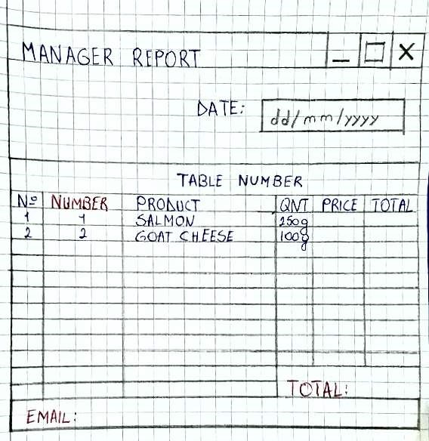
APPENDIX - SKETCHES

